MODULE 4 – INTRODUCTION TO DBMS

LAB EXERCISES

8. UPDATE Command
Lab 1.
Update the year_of_publication of a book with a specific book_id.
Ans.
1. UPDATE books SET year_of_publication = 2022 WHERE book_id = 1;

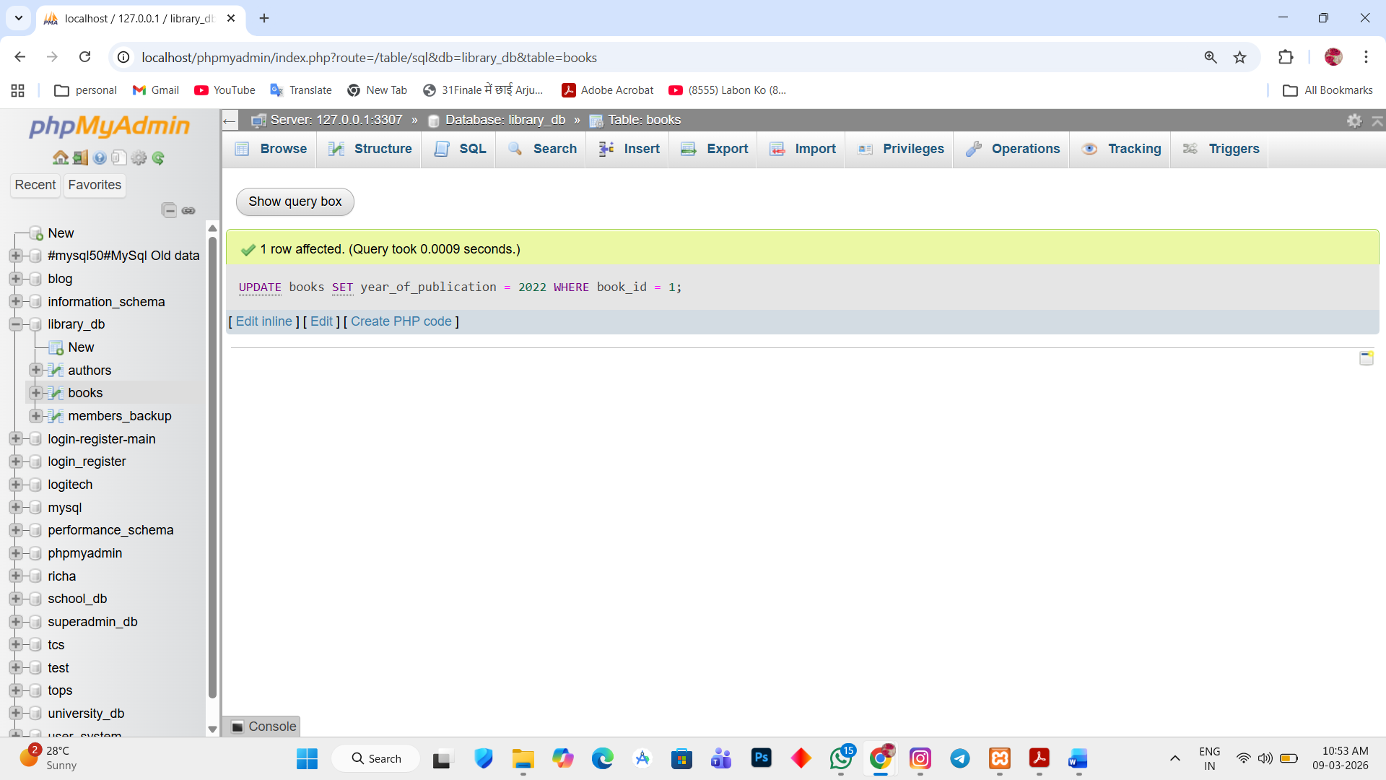

Lab 2.
Increase the price of the all books published before 2015 by 10%.
Ans.
1. UPDATE books SET price = price + (price * 0.10) WHERE year_of_publication < 2020;

